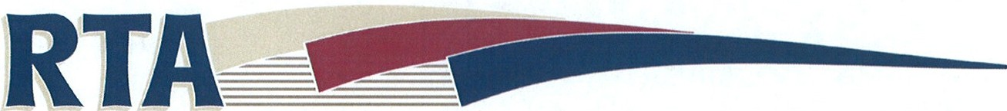
Delaware Dubuque Jackson County Regional Transit Authority
Reasonable Modification Request
Use this form to request a reasonable modification to current RTA policies or procedures. Be specific and provide as much information as possible. This will allow us to effectively process and evaluate your request. Before filling out this form, please review RTA’s Reasonable Modification Policy.
Please include in your statement: 1)why this modification is necessary and 2)provide a brief description of your limitation(s)
Name: ____________________________________________________
Address: ___________________________________________________
City: _________________________ State: ______________ Zip: ____________
Telephone number: _______________________________________
E-mail: ________________________________________

Modification Request: ___________________________________________________________________________________________________________________________________________________________________________________________________________________________________________________________________________________________________________________________________________________________________________________________________________________________________________________________________________________________________________________________________________________________________________________________________________________
Please send by:
Fax: (563) 557-3716
Email: cravada@ecia.org
Mail: Chandra Ravada, 7600 Commerce Park, Dubuque IA 52002

All information will be kept confidential.
------------------------------------------------------------------------------------------------------------------------------------------
Office use only: Received _____________ By ______________ Notes _____________________

